26.AIM:- *To draw the UML diagrams for jewellary shop management system using umbrello.*

***USE CASE DIAGRAM:***

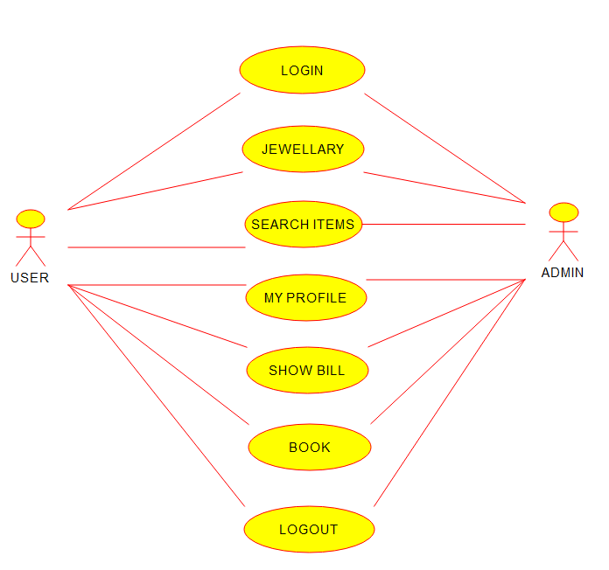

***SEQUENCE DIAGRAM****:*

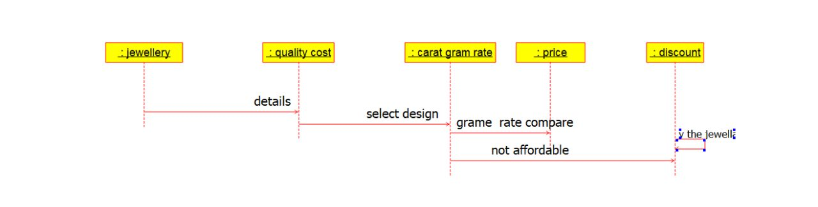

***COMPONENT DIAGRAM:***

